**INTI International College Penang School of Computing**

**3+0 Bachelor of Science (Hons) in Computer Science, in collaboration with Coventry University, UK 3+0 Bachelor of Science (Hons) in Computing, in collaboration with Coventry University, UK**

# Coursework cover sheet

**Section A - To be completed by the student.**

|  |  |
| --- | --- |
| Full Name: JAYASHREE A/P ELUMALAI | |
| CU Student ID Number: 14196184 | |
| Semester:1 | |
| Session:  **April 2023** | |
| Lecturer:  **Puteri Nursyawati Azzuri (puteri.azzuri@newinti.edu.my)** | |
| Module Code and Title:  **4067CEM Software Design** | |
| Assignment No. / Title:  **Continuous Assessment** | % of Module Mark:  **50** |
| Hand out Date:  **12 May 2023** | Due Date:  **Task 4: 7 July 2023, by 11.59pm.** |
| Penalties: No late work will be accepted. If you are unable to submit coursework on time due  to extenuating circumstances, you may be eligible for an extension. Please consult the lecturer. | |
| Declaration: I/we the undersigned confirm that I/we have read and agree to abide by the University regulations on plagiarism and cheating and Faculty coursework policies and procedures. I/we confirm that this piece of work is my/our own. I/we consent to the appropriate storage of our work for plagiarism checking.    Signature(s): | |

# Section B - To be completed by the module leader

|  |  |  |
| --- | --- | --- |
| Intended learning outcomes assessed by this work:   1. Understand and apply appropriate concepts, tools, and techniques to each stage of the software development. 2. Understand and apply design patterns to software components in developing new software. 3. Demonstrate an understanding of project planning and working to agreed deadlines, along with professional, interpersonal skills and effective communication required for software production.   5. Demonstrate an awareness of, and ability to apply, social, professional, legal, and ethical standards as documented in relevant laws and professional codes of conduct such as that of  the Malaysian National Computer Confederation. | | |
| Marking scheme | Max | Mark |
| 1. User Story Mapping | 20 |  |
| 2. Setting up a GitHub |  |
| Repository | 10 |
| 3. Creating a Class diagram and |  |
| design pattern selection | 30 |
| 4. Creating a Prototype User |  |
| Interface and Usability Testing | 20 |
| 5. Discuss the ethical issue |  |
| related to the software | 20 |
| Total | 100 |  |

Editing Cart Function

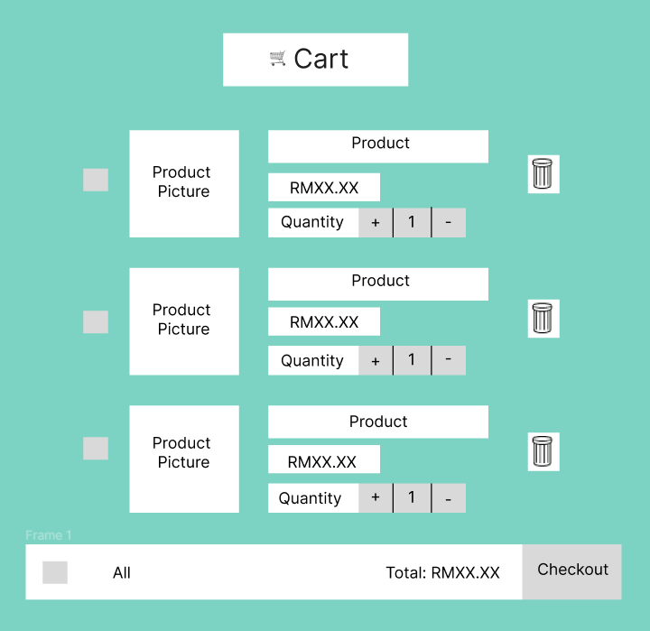

Figure 1

Figure 1 shows the cart page. The ‘🛒 Cart’ is displayed at the top of the cart page indicating that this is the cart of the customer. The important function of the proposed system is editing the cart. The customers can select the product they want to order by selecting the rectangle buttons on the left of the products. Each product added to the cart is displayed with its picture, product name, the price and the quantity of the product the customer would like to order. They can select the ‘+’ button to increase the quantity and select the ‘-‘ button to decrease the quantity. The number in between the ‘+’ and ‘-‘ buttons displays the number of quantity selected. The bin symbol (🗑)displayed on the right end of each product is used to delete the product from the cart. Customers can also click the rectangle ‘All’ button on the right at the end of the page to select all the products in the cart. The ‘Total’ shows the total amount of the products selected. Beside the ‘Total’ there is a ‘Checkout’ button which can be clicked to checkout where the order can be confirmed.

Usability testing

Testing edit cart function

Objective: Assess the user experience and effectiveness of the cart editing process

* How simple was it to change the product quantities in your cart?
* Can the users comprehend how to edit the cart's contents?
* Have there been any problems or misunderstandings with the cart update?
* How soon were modifications to the cart such as removing, updating, or adding the products made?
* Can users select the products to order after selecting the square button on the left of the products?
* Are all the products in the cart selected after selecting the ‘All’ button?
* Does the total show the accurate total amount of the selected products?

Testing the delete button

Objective: Examine the functionality and effectiveness of the delete button

* Do users understand that the bin represents the delete function?
* Can the delete button be located easily?
* Is the product deleted from the cart after selecting the delete button?

Testing the add and reduce quantities button

Objective: Examine if the add and reduce quantities button works well

* Do the users comprehend that the ‘+’ symbol adds the quantity of the product?
* Can the users understand that the ‘-‘ symbol reduces the quantity of the product?
* Is the quantity added after selecting the add quantity button?
* Is the quantity reduced after selecting the reduce quantity button?

Make payment function

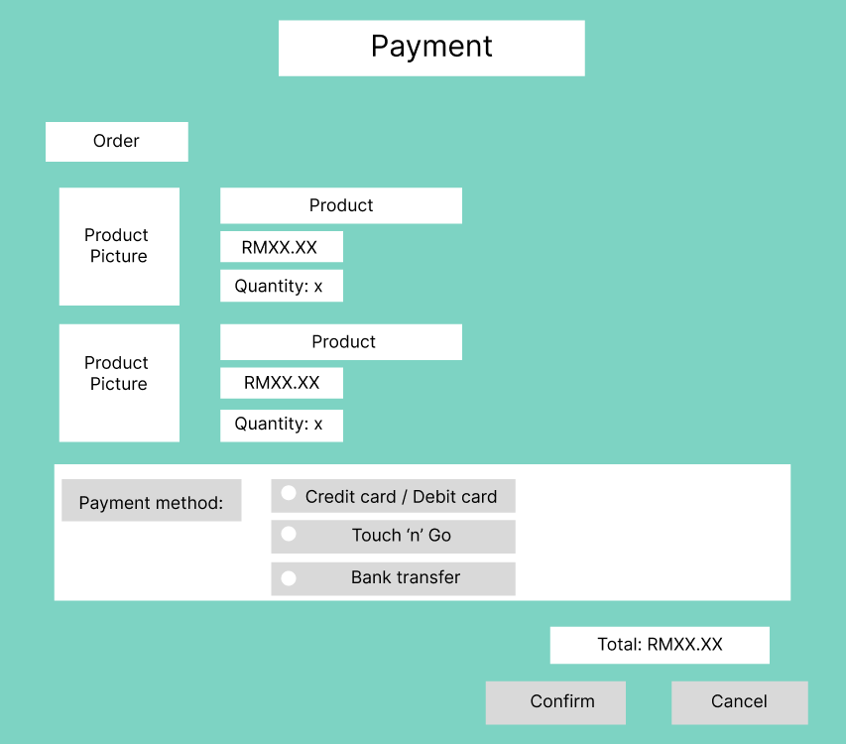

Figure 2

Figure 2 shows the payment page. The other important function of the proposed system is making payment. There is ‘Payment’ displayed at the top to the page indicating it is the payment page. Then, the order is displayed with the products including its pictures, chosen quantity and the price according to the quantity. Users can select the payment method by clicking either one the payment methods which are ‘Credit card / Debit card’ or ‘Touch ‘n’ Go’ or ‘Bank transfer’. When users click their preferred payment method, it will lead them to another page to fill in the details of their payment method and it will be verified. The ‘Total:’ displays the total amount of the order. Lastly the users can select the ‘Confirm’ button displayed at the bottom to confirm the payment or they can select the ‘Cancel’ button displayed at the bottom right to cancel the payment.

<https://www.figma.com/file/cnqchnDkNt8dSG96b8uJjO/Prototype?type=design&node-id=0-1&mode=design&t=GmTOjczLE7NzBKqf-0>

Usability Testing

Testing make payment function

Objective: Examine how well the "Make Payment" function works and how easy it is to use in the clothing ordering system.

* Are the products shown in the payment page the same as the customer ordered?
* Are the quantities of the product are as chosen by the customer?
* Is the price of the product shown accurate?
* Is the total amount of the order tally?

Testing choosing payment methods

Objective: Assessing the simplicity of choosing the payment method

* How simple was it to choose the payment methods (Credit card/Debit card, Touch ‘n’ Go, Bank transfer)?
* Can the users fully comprehend the various payment alternatives and how they differed?
* Did the system navigate to a different window to let the users enter the details for the payment method chosen?

Testing the confirm button

Objective: Assessing if the confirm button works effectively

* Can the users understand the function of the confirm button?
* How simple was it to locate the ‘Confirm’ button?
* Were there any problems or misunderstandings when confirming the payment?
* Was the payment confirmed after selecting the confirm button?
* How fast was the process to confirm the payment?

Testing the cancel button

Objective: Assessing the functionality of the cancel button

* Do the users understand that when they click the cancel button it cancels the payment?
* Is the payment cancelled after selecting the cancel button?
* How simple was it to locate the ‘Cancel’ button?
* Were the any issues to can cancel the payment?
* Did the process of cancelling the payment take a long time?